**SEVENTH FRAMEWORK PROGRAMME**

**THEME 7 – TRANSPORT (INCLUDING AERONAUTICS)**



**Collaborative Project**



Project Acronym: **SaferBraIn**

ProjectCoordinator: **MOBYCON (The Netherlands)**

Proposal full title: **Innovative Guidelines and Tools for Vulnerable Road Users Safety in India and Brazil**

Grant Agreement n°: **233994**

Document Title: **Case Study Sao Paulo in WP1**

Author: **FUSP**

Summary: This report presents a case study on traffic situations in Sao Paulo (Brazil)

Distribution: **Website**

Date: **21.06.2010**

# Sources of Local Data on Road Safety and the VRU Safety Problem for the City of São Paulo

In Brazil, most of the time are Local Road Authorities in charge of responsibilities in the traffic safety area and have to build their own databases on accident records. The usual approach to this task is to establish some kind of extra-official arrangement with Police Authorities to have access to police records related to traffic accidents. In Brazil as a rule, there are two official Police bodies at the state level: A Civil Police (dealing with crime deterrence and investigation in general) and a Military Police (that has the task of ostensive policing and diligence as prevention or deterrence). Some cities also have their own Police body (a Municipal Guard that takes care of municipal properties and prevention).

Some Local Road Authorities go a step further and try to complement this source of information with additional data from Health Institutions (Local and Regional Hospitals) and Coroners Institutes (Legal Medicine Institutes, as named in Brazil). Other Local Road Authorities organize an independent data collection team on the traffic accidents occurring on roads under their jurisdiction. Both expedients are used in the City of São Paulo as described ahead.

In the following, we will present information on the general/comprehensive traffic accident databases and on the detailed/complementary accident databases available at the City of São Paulo. The major source is Paula (2009).

Before starting, one should remind that the City of São Paulo has more than 10 million inhabitants (heading a Metropolitan Area with more that 25 million inhabitants). CET/Sp-the Traffic Engineering Company of the Prefecture of São Paulo is a large public enterprise. For the operational management of traffic, CET/Sp is divided in 6 Traffic Engineering Management Units of CET/Sp (called GETs), that are further divided in smaller Field Engineering Departments (called DECs, that amounts to 24 departments for the City of São Paulo, in all the 6 GETs). The rule applies: Big city, huge problems.

1. **General/Comprehensive Traffic Accident Databases in the City of São Paulo.**

Traffic Accident Databases are defined as general or comprehensive when they are intended to cover all the occurrences of the traffic accidents eligible to be recorded in the City of São Paulo.

In the City of São Paulo, CET/Sp has maintained an agreement with Police Authorities with a hole in time on data acquisition for the years 2000 to 2004 (due to the reorganization of the Police data processing system in the years from 2000 to 2004, the data collection effort was suspended). Previously, data from the Civil and Military Policies were gathered separately from paper forms and had to be evaluated for duplication. The Military Police had a special procedure (and a special body of personnel for some periods) for dealing with traffic occurrences in the City of São Paulo and this fact provided relevant data on all kind of traffic accidents. The Civil Police kept record of traffic accident mainly for injury accidents only, and some accidents were recorded in both sources (then the need for checking for duplication).

Nowadays CET/Sp receives data regularly, each month, in digital format (on a CD), as stored in INFOCRIM-the computerized information system on criminal information of the Civil Police of the State of São Paulo. All records related to traffic accidents and also to occurrences with culpable bodily injury (“Lesão Corporal Culposa”) or hit and run accidents (“Omissão de Socorro”) are sent to CET/Sp for screening and selection of traffic accident records by their own personnel. In this new source of information, data on PDO accidents are generally missing and the current database, after 2005, focus almost exclusively on injury and fatal accidents. Data are referenced to road locations by number or junction and loaded to a GIS system based on the MapInfo desktop mapping tool.

Data collection from the IML, the Legal Medicine Institute, is also regularly gathered on fatalities resulting from traffic accidents. Nowadays, the IML data is the main source of data on fatal traffic accidents for CET/Sp. Data on fatal and injury accidents from the Police records are used for matching fatalities to accidents, and also for checking and complementing information on location and time of occurrences. Note that data from Police records usually classify fatal accidents based on fatalities occurring on the scene of accident while data from IML record all fatalities that can be traced to a traffic accident as its initial occurrence, providing information on the date of death and approximate information on the date of the traffic accident that generated it (and some of its features).

Previously, both sources of data were joined in a common database. Nevertheless, data on fatal accidents from the IML is usually rich in content and the quality of information is judged to be better. From 2005, the traffic accident data is managed by two related databases: the SAT, the information system on traffic accidents, and the SAF, the information system of fatal traffic accidents. After 2007, data on fatal traffic accidents from the SAF is advanced to the operational units of CET/Sp for each month with a time lag of one to two months, adding information to their local observation so as to improve their monitoring of traffic safety problems. Also, in this occasion, data on the SAF is supplied to the SAT database. Data from the SAT database is available to the operational units of CET/Sp in the company intranet by location and type of accident, with an additional time lag around 3 to 6 months, including a wide time span (actually since 2005).

The SAT database is geo-referenced and has information on date and location, accident type, number and type of vehicles involved, number and type of victims produced. Data on the Police record reference number is also stored to easy the access to the original data source. The link of victims to vehicles is not clear. SAT was developed first and had detailed data on vehicle identification that was abandoned in the current work process.

As an example, for 2008, around 6 to 7 thousands police records are screened in each month, from which a third are traffic accident records. The effort is carried-out by a team of 4 officers for reading, selecting and digitizing accident data records. A supervisor conduct the work and manage the SAT and the GIS system. For the year of 2008, there were 27.739 injury accidents (7.602 pedestrians accidents).

The SAF database has the same information of SAT (despite not being geo-referenced) and has additional data on victims of fatalities. The data form changed several times during recent years up to the more recent version. The last version, adopted in June of 2009, includes age, sex and occupation of each victim identified and makes a clear link of victims to their vehicles. A short description of each accident is also inserted as a special field, when there is information available in the accident or fatality records.

As an example, again for 2008, around 250 records, from the 8 hundred produced by IML in the City of São Paulo, are gathered and screened in each month, from which less than 50% are fatalities from traffic accidents. The effort is carried-out by a team of a supervisor and 2 officers that extract data and store them in computerized worksheets, match them to Police records and join the content of both sources. For the year of 2008, there were 1.463 fatalities from traffic accidents (670 pedestrians, 69 cyclists and 478 motorcyclists).

Currently, the integration of SAT and SAF are being strengthened. The data form for gathering Police record data was redesigned to fit SAF data fields. Data for 2009 is being collected in a new compatible form for SAT and SAF. However, the effort of adapting computerized systems for the integration of both sources is to be carried-out yet. New resources for data access through the internet are also being planned for the near future.

However, both SAT and SAF databases lack of integration to a database on road features, a feature that seems to be the main weak point of the current data system for use in general accident analysis. This deficiency is not a major problem for analysts by the operational units (DECs) of CET/Sp because they have detailed knowledge on their road system. The analyses of local features of sites are also mandatory for further investigation of road safety problems and for the design of countermeasures. Nevertheless, the identification of general strategies for tackling road safety problems could benefit from integrated data on the road system. The lack of quality in both sources of traffic accident data is another problem.

1. **Detailed/Complementary Traffic Accident Databases in the City of São Paulo.**

Traffic Accident Databases are defined as detailed or complementary when, despite usually providing better and more extensive data on the events, they are not intended to cover all the occurrences of the traffic accidents eligible to be recorded in the City of São Paulo.

Along the time, CET/Sp tried several complementary sources of information, from in-depth studies of accidents or their victims (using on the scene investigations or following victims of accidents in hospitals) to the filling of accident reports with their own personnel. Due to the dimension of the effort needed to maintain such data collections systems in the City of São Paulo, most of these efforts were temporary or even eventual. This situation shows that these efforts are taken as less important than the more demanding tasks of traffic management.

The more long-standing effort in the collection of complementary data on traffic accidents was reintroduced in 2005: On the scene data collection on more severe traffic accident data by trained technicians of CET/Sp. The same approach was tried in the past and generated the RAT (Reports on Traffic Accidents). The recently reintroduced approach tried to improve the data collection method based on accident reconstruction procedures and generates the RIF-the Report on Investigation of Fatal and Special Traffic Accidents.

A team led by a technical supervisor and composed by 5 trained technicians schedule to cover 24 hours per days and 7 days per week try to gather information on all traffic accidents that generate fatalities on the site or that has large (special) impact. The coverage is not complete but the quality of data is felt to be much better than that available in other sources.

As an example, for 2008 again, the investigations gathered information of 253 fatal accidents (72 being pedestrian accidents) that amounts to 279 fatalities of the 1.463 fatalities of the year (19%). Data for each accident includes testimony on the accidents or description from public agents that came to the scene, review of site features and accident marks, sketches on the accident scene, photographic documentation and judgements on contributory factors and possible countermeasures to the risk of similar accidents. A standardized data form (the IAT) is also filled by the trained technicians (despite the preference for the free report).

Actually, for each accident, two reports are generated: a short report to be sent to the operational units and to the general management of CET/Sp up to the day after the accident; a full report that is included in a monthly report set to the traffic safety management for further analysis. These detailed reports and their data forms constitute the SAI, an informal information systems on traffic accident investigations, held by the Traffic Safety Management Unit of CET/Sp.

The same data form (IAT) is also available to technicians of the operational units of CET/Sp and they are asked to fill it when they come to the scene of a traffic accident (whatever its level of severity) if the conditions at the scene permits (due to the priority given to the tasks of isolating the site, attending to the victims and to the police agents, and managing the resulting traffic conditions). The level of coverage of this additional source of IATs is largely variable, depending on the level of commitment and availability of the field personnel and managers of the operational units of CET/Sp.

At this time, both sources are meant to provide qualitative data that are felt to be more reliable and that can contribute to a better understanding of accident factors.

# The Data Collection Effort and the Organization of Project Databases

The data for the City of São Paulo collected for this case study can be categorized in two groups: general data provided in aggregate form (covering a large time span and used for grasping tendencies of the traffic safety problem) and detailed data on VRU traffic accidents (limited to the years of 2009 but extended to previous year if mandated by the need of a larger sample to be used in the characterization of the main features of VRU traffic accidents).

On general data, we built a basic database on total injury and fatal accidents, for each road user type (as published in official reports from CET/Sp), on population (estimated, by gender and age) and fleet (from yearly licensed fleet, by vehicle type). These data are summarized in Table 7.2.3.3.1 and Table 7.2.3.3.2 (both will be discussed ahead) and taken from official reports from CET/Sp (CET/Sp 1998, 2001, 2006, 2010).

A GIS database for the City of São Paulo was also supplied by CET/Sp, including a general database of road segments and the definition of their operational units for traffic management (GETs and their DECs, as shown in Figure 9.2.3.3.1).

**Table 7.2.3.3.1 - General Data on Fatalities in Traffic Accidents for the City of São Paulo (CET/Sp/DATASUS)**

|  |  |  |  |  |  |  |  |  |  |  |  |
| --- | --- | --- | --- | --- | --- | --- | --- | --- | --- | --- | --- |
| Year | Total Fatalities | Pedestrians | Cyclists | Motorcyclists | Drivers and Passengers | Vehicle Occupants | DATASUS Total | DATASUS Pedestrian | DATASUS Cyclists | DATASUS Motorcyclists | DATASUS Others |
| 1980 | 2330 | 1580 |  |  |  | 750 |  |  |  |  |  |
| 1981 | 2365 | 2365 |  |  |  | 688 |  |  |  |  |  |
| 1982 | 2267 | 1486 |  |  |  | 781 |  |  |  |  |  |
| 1983 | 2262 | 1394 |  |  |  | 868 |  |  |  |  |  |
| 1984 | 2490 | 1489 |  |  |  | 1001 |  |  |  |  |  |
| 1985 | 2559 | 1515 |  |  |  | 1044 |  |  |  |  |  |
| 1986 | 2885 | 1812 |  |  |  | 1073 |  |  |  |  |  |
| 1987 | 2981 | 1751 |  |  |  | 1230 |  |  |  |  |  |
| 1988 | 2790 | 1677 |  |  |  | 1113 |  |  |  |  |  |
| 1989 | 2652 | 1579 |  |  |  | 1073 |  |  |  |  |  |
| 1990 | 2715 | 1621 |  |  |  | 1094 |  |  |  |  |  |
| 1991 | 2686 | 1593 |  |  |  | 1033 |  |  |  |  |  |
| 1992 | 2291 | 1328 |  |  |  | 963 |  |  |  |  |  |
| 1993 | 2436 | 1494 |  |  |  | 942 |  |  |  |  |  |
| 1994 | 2401 | 1469 |  |  |  | 932 |  |  |  |  |  |
| 1995 | 2278 | 1432 |  |  |  | 846 |  |  |  |  |  |
| 1996 | 2245 | 1339 |  |  |  | 906 |  |  |  |  |  |
| 1997 | 2042 | 1109 | 30 | 221 | 682 | 821 | 2182 | 1208 | 3 | 16 | 955 |
| 1998 | 1558 | 933 | 29 | 212 | 384 | 866 | 1576 | 906 | 1 | 17 | 652 |
| 1999 | 1683 | 862 | 48 | 245 | 528 | 821 | 1658 | 834 | 11 | 48 | 765 |
| 2000 |  |  |  |  |  |  | 720 | 284 | 1 | 29 | 406 |
| 2001 |  |  |  |  |  |  | 1675 | 774 | 22 | 125 | 754 |
| 2002 |  |  |  |  |  |  | 823 | 342 | 10 | 37 | 434 |
| 2003 |  |  |  |  |  |  | 1527 | 681 | 24 | 100 | 722 |
| 2004 |  |  |  |  |  |  | 1445 | 680 | 18 | 140 | 607 |
| 2005 | 1505 | 748 | 93 | 345 | 319 | 757 | 1579 | 750 | 41 | 175 | 613 |
| 2006 | 1487 | 734 | 84 | 380 | 289 | 736 | 1587 | 790 | 89 | 384 | 324 |
| 2007 | 1566 | 736 | 83 | 466 | 281 | 830 | 1643 | 715 | 50 | 323 | 555 |
| 2008 | 1463 | 670 | 69 | 478 | 246 | 793 |  |  |  |  |  |
| 2009 | 1382 | 671 | 61 | 428 | 222 | 711 |  |  |  |  |  |

### Recent Trends on the Road Safety Problem and the Situation of VRUs in the City of São Paulo/Brazil

As shown in Table 7.2.3.3.1 and Table 7.2.3.3.2, general data on traffic accidents in the City of São Paulo is available systematically since 1980. Nevertheless, initially the data on fatalities identified only vehicle and pedestrian user classes (vehicle users including motorcyclists, cyclists and all other vehicle users). For recent years (since 1998, with the data hole from 2000 to 2004), overall figures are given for pedestrians and for occupants of bicycles, for occupants of motorcycles and for drivers and passengers, separately, of other vehicles.

The general chart of global data on traffic safety problems in the City of São Paulo is shown in Figure 9.3.5.1.1 (total number of traffic accident fatalities, including the contribution of each road user class).

The comparison of the general trend of traffic accident fatalities, population and fleet in the City of São Paulo is shown in Figure 9.3.5.1.2 and the corresponding numbers for accident rates are shown in Figure 9.3.5.1.3.

The most notable change has occurred in the trend on the share of each road user class in traffic accidents fatalities, as shown in Figure 9.3.5.1.4.

Each one of these figures is shortly discussed in the following.

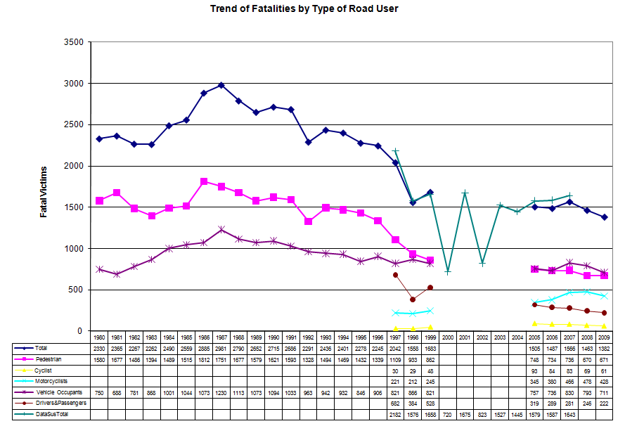

Figure 9.3.5.1.1 – Numbers on Traffic Accident Fatalities in the City of São Paulo

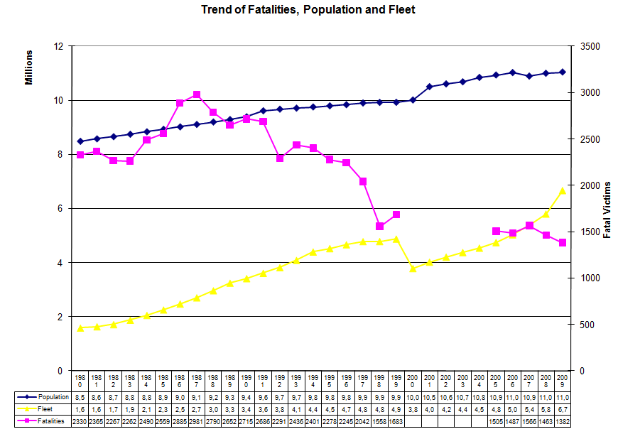

Figure 9.3.5.1.2 – Comparison of Trends on Traffic Accident Fatalities, Population and Fleet in the City of São Paulo

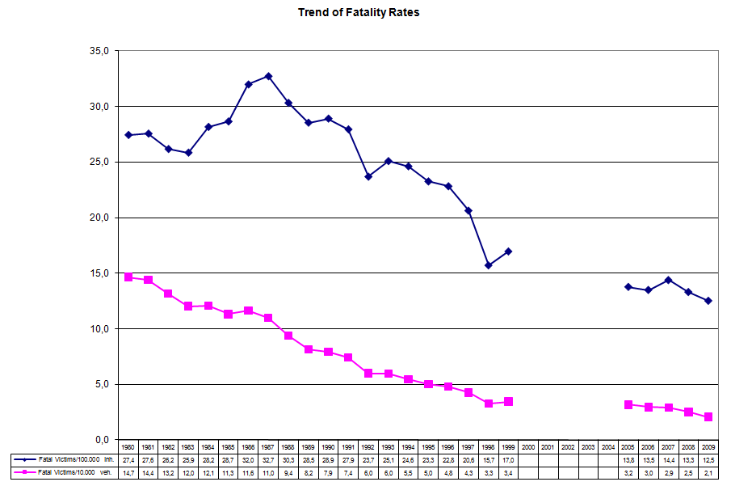

Figure 9.3.5.1.3 – Traffic Accident Fatality Rates per 100000 inhabitants and per 10000 vehicles in the City of São Paulo

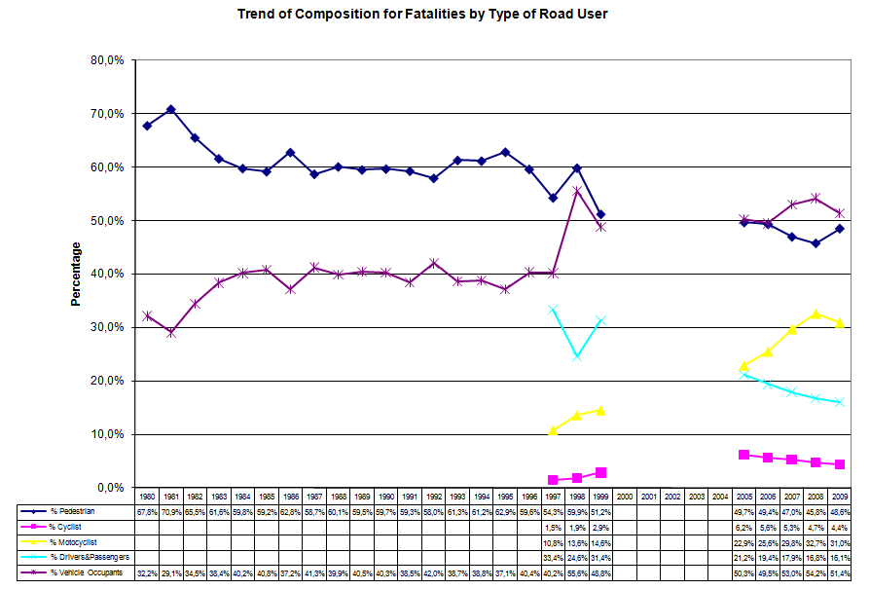

Figure 9.3.5.1.4 – Composition of Traffic Accident Fatality by Road User Type in the City of São Paulo

As can be seen in Figure 9.3.5.1.1, the total number of accidents peaked at 1987 (the rate per 100.000 inhabitants also peaked at 1987, as displayed in Figure 9.3.5.1.3) and showed a steadily decrease since then of around 3,6%a.a., with sharp falls in 1992 and 1998. The year of 1992 had the introduction of a municipal law ordering the mandatory use of seat belts, in the City of São Paulo (it became mandatory in the country only with the new traffic code in 1998). This first jump can be explained by the strong enforcement activity that followed the introduction of the municipal law (this can be argued because the number of pedestrian fatalities also had a sharp decrease in that year, being not attributable to seat belts). The year of 1998 was the first year of the new traffic code (the CTB, approved in 1997). Taking 1997/8 as an inflection point, the rate of decrease in the number of traffic accident fatalities is roughly the same before and after the approval of the new traffic code: 3,9%a.a. before and 3,3%a.a after the year of 1997. This feature suggests that the rate of decrease is largely attributable to (long range) trends on motorization, familiarity to traffic operation, general information and education, improved infra-structure and management, among others.

Due to the strong trend of the vehicle fleet growth, the rate per 10.000 vehicles is continuously decreasing during all the analysis period, despite some minor fluctuations in some pair of years (attributable to administrative revision of the databases). This pattern of evolution is usual in countries where the rate of motorization is still increasing sharply (the rule in emerging economies), showing that this rate is not amenable to easy use for analysing changes in traffic safety for this setting. The increase of the motorization rate is clear (the relative trend of growth on fleet is greater than that on population). Note, however, that data on fleet are strongly debated in Brazil and average numbers hide a situation of inequality in the access to private transport (or in the dependence on public transport). The City of São Paulo is a clear sign of this point. From data estimated using the 2007 Origin/Destination Survey, the estimated fleet of automobiles in households is 2.103.342 automobiles (less than half the number of automobiles registered in official files) and the proportion of households without car is 49,4% (it is hard to grasp the reliability of each of these sources but the sign of a large proportion of careless households seems clear).

Nonetheless, the more important changes have occurred in the participation of road user types in traffic accident fatalities. Despite remaining the large group affected by fatalities during all the analysis period (1980 to 2009), the presence of pedestrians is decreasing and is approaching the 50/50 share in recent years. The major changes, however, occurred in the composition of fatalities for vehicle occupants. The increase in the participation of vehicle occupants is almost exclusively attributable to motorcyclists. In the City of São Paulo, the number of fatalities to motorcyclists surpassed that of drivers and passengers of all other motorized vehicles in 2005 and is now around the double of them (in 2009, 31,0% of motorcyclists against 16,1% of drivers and passengers of all other vehicles). The share of fatalities of non-motorized vehicles (whose participation in general traffic is very small in the City of São Paulo) is generally included in figures for pedestrians, but for bicycles. For cyclists, from 1997 (when CET/Sp started their consideration in separate, with the hole in the time span of data from 2000 to 2004) there were a steady increase up to 1999 and then a steady decrease from 2005 on (the inflection point seems to occur in some year between 2000 to 2004, from which data are missing in the City of São Paulo).

A better picture on the safety of travelling by each mode of transport can be seen when considering data on the number of trips (or trip-km) done using each option. Based on published data from the 2007 Origin/Destination Survey, in a typical work day, the number of trips was 21,64 million, with 34% of non-motorized trips (7,14 millions by walking and 0,12 million by cycling). These figures are for modes of travel (as classified by the main mode of travel used in each trip), not by modes of transport (a travel mode can combine several transport modes to complete a trip). However, the relative numbers are clear in suggesting that the safety problem is really worse for non-motorized road users (the vulnerable). If preferring the analysis by trip-km, the situation seems to be even more clear, considering that motorized trips are longer than non-motorized ones.

# Global Data on the Road Safety Problem and the Situation of VRUs in the City of São Paulo/Brazil

The analysis of data on the road safety problem for VRUs will add gender, age class and spatial dimension to the overall data previously presented. To get these details, the analysis used new databases on traffic fatalities in the City of São Paulo gathered for the project.

Initially, the analysis used data from 2009. Nevertheless, to increase the database on cyclist fatalities (and achieve more faithful results), data on fatalities in 2008 were added for cyclists.

Overall, we will be analysing 649 pedestrian fatalities and 124 cyclist fatalities. These numbers are smaller than the official numbers (691 fatalities for pedestrians in 2009 or 130 fatalities for cyclists in 2009/8) because some occurrences were lost in the data recollection process. Nevertheless, they are representative of the situation (noting that pedestrian data were collected for one year and cyclist data were collected for two years). Note that the level of fatality for pedestrians in the City of São Paulo is similar to that observed in all the UK and that the level of fatality to cyclists in the City of São Paulo is half that of the UK, for each year (total deaths in traffic accidents in London was 205 in 2008, motorized and non-motorized, a much better score even considering that the City of São Paulo has 10 million inhabitants).

The fatalities of pedestrians and cyclists by type of area are represented in the maps and tables shown in Figures 9.3.5.2.1a and 9.3.5.2.1b. One can see that there is a small loss of information on accident location for pedestrian and cyclist fatalities. Also, in both cases, there is a concentration of fatalities in the Surroundings and Fringe area types, where there is also a concentration of population. Unfortunately, there is no information on exposure measures for pedestrians and cyclists in each type of area (population is not good as a measure of exposure, at least for pedestrians in the Central Area). The conditioning effect of the (lack of) provision of infra-structure for non-motorized users must also be taken into account when evaluating the patterns of distribution observed, as discussed ahead.

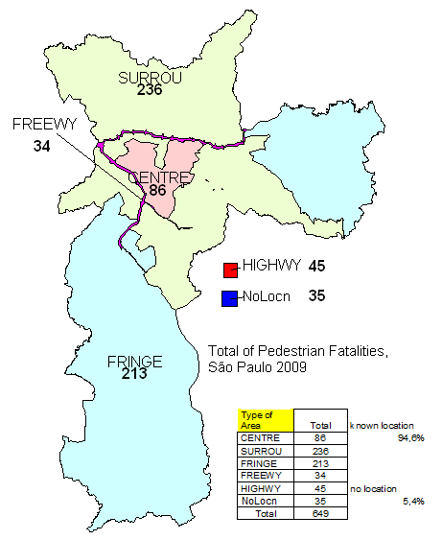

Figure 9.3.5.2.1a – Pedestrian Fatalities by Type of Area in the City of São Paulo in 2009

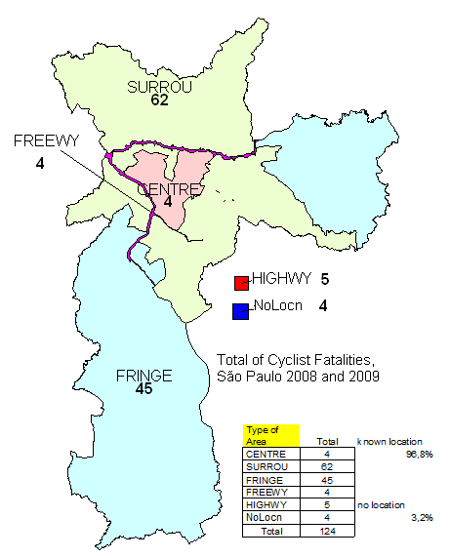

Figure 9.3.5.2.1b – Cyclist Fatalities by Type of Area in the City of São Paulo 2009&8

The incidence of fatalities in traffic accidents for pedestrians and cyclists by age group and type of area are represented in the maps and tables shown in Figures 9.3.5.2.2a and 9.3.5.2.2c (the corresponding shares are shown in the maps and tables shown in Figures 9.3.5.2.2b and 9.3.5.2.2d). Age Groups were defined based on the following criteria:

|  |  |  |
| --- | --- | --- |
| Age Groups | From Age/To Age | |
| Children | 0 | 15 |
| Youngers | 16 | 24 |
| Adults | 25 | 59 |
| Olders | 60 | - |

(the frontiers between age groups is disputable; this criteria has the advantage of permitting to calculate population by age groups from standard tables of population per range of age, that are usually presented in 5-year bins).

The incidence of fatalities in traffic accidents for pedestrians and cyclists by gender and type of area are represented in the maps and tables shown in Figure 9.3.5.2.3a and 9.3.5.2.3c (the corresponding shares are shown in the maps and tables shown in Figures 9.3.5.2.3b and 9.3.5.2.3d).

The combined incidence of fatalities in traffic accidents for pedestrians and cyclists by age group and gender are shown in Tables 7.3.5.2.1a and 7.3.5.2.1b.

The incidence of fatalities in traffic accidents for pedestrians and cyclists by period of day and type of area are represented in the maps and tables shown in Figure 9.3.5.2.4a and 9.3.5.2.4c (the corresponding shares are shown in the maps and tables shown in Figures 9.3.5.2.4b and 9.3.5.2.4d). Periods of the day were defined based on the following criteria:

|  |  |  |  |
| --- | --- | --- | --- |
| Periods of Day | From Hour/To Hour | | |
| Late Night | | 00:00 | 04:00 |
| Early Morning | | 04:00 | 06:00 |
| Morning | | 06:00 | 11:00 |
| Mid Day | | 11:00 | 14:00 |
| Afternoon | | 14:00 | 18:00 |
| Early Night | | 18:00 | 20:00 |
| Night | | 20:00 | 00:00 |

(the frontiers between time periods is disputable and surely would be better made dependent of the season on the year or any other similar reference and also vary by country). However, it was felt that another distinction is more relevant: to distinguish late night periods of weekends from work days. At least for younger drivers and passengers, there is strong evidence showing that their presence in fatal accidents is greater in this type of period.

On the incidence of fatalities to pedestrians in age groups shown in Figures 9.3.5.2.2a and 9.3.5.2.2b, the data clearly show that adults and elderly are the most affected. As typically adults and elderly are around 49,8% and 11,9% of the population, the higher relative incidence in the elderly group is evident. For children, that typically amounts to around 24,0% of the population, the incidence is relevant only in Surrounding Areas and Fringe Areas. This pattern can be naturally traced back to the larger share of residential areas outside the Central Areas (where the incidence on children is small). The presence of Adults is clearly dominant in relative numbers only in high speed roads (Freeways and Highways), signing a predisposition to be in risk as pedestrians in these roads that seems to be absent in other groups. Overall, the incidence in young people is relatively small, despite being relevant yet, and the level of abnormal incidence in elderly and children is surely of special concern.

On the incidence of fatalities to cyclists in age groups shown in Figures 9.3.5.2.2c and 9.3.5.2.2d, the predominance of adults is clear in absolute and relative number but now the presence of children and youngish in decisively important, especially in relative terms as youngish typically represent 14% of the population (around a quarter the share of adults). It is also surely relevant for children (around half the share of adults in population). The absence of incidence in older groups is also clear. Again, the same spatial pattern of presence of problems concentrated in the Surrounding Areas and Fringe Areas occur for children, but now the same pattern is observed for adults and younger people. The absence of incidence in Central Areas could be related to the lack of infra-structure (at least). The same pattern of absence can be found in high speed roads in São Paulo (Freeways and Highways). Again, the lack of infra-structure could be suggested as an explanation. Due to the high congestion level on these roads, their shoulders were usually converted to traffic lanes in the major portion of their extension (in support of this hypothesis, it is notable that the presence of fatalities to cyclists appears on highways outside the City of São Paulo).

The incidence of fatalities to pedestrians and cyclists in gender as shown in Figures 9.3.5.2.3a, 9.3.5.2.3b, 9.3.5.2.3c and 9.3.5.2.1d, are opposite, relative to the normal incidence in fatalities in traffic accidents (where males are predominantly affected as a rule). For pedestrians, the presence of females (even if smaller than that of males) is more significant than usual, mostly in areas where residential activity is predominant (the Surroundings and the Fringe areas). For cyclists, the predominance of males is almost absolute (the presence of females is significant only in Central areas, a weak result given the very small sample of cyclist fatalities in this type of area). Based on the 2007 Origin/Destination Survey, the number of non-motorized trips per day is 3,10 million for males and 4,04 million for females (larger for women) for pedestrians and 0,12 million for male and 0,014 for female for cyclists (ten times greater for men). Part of the explanation is the exposure measure but the riskier behaviour of men also seems to be present as the source of this pattern.

The cross tabulation of fatalities by age and gender shown in Table 7.3.5.2.1a and 7.3.5.2.1b also reveals some specific features. Mainly, note the peak of incidence on female (older) fatalities for pedestrians (reaching 39,38% where the average is 27,31%, as elderly are 50,38% of pedestrian fatalities among women) and for younger cyclists (reaching 12,00% where the average is 5,65%). The presence of different user groups among pedestrians and cyclists (in particular for young cyclists) can explain the variation in the pattern of incidence.

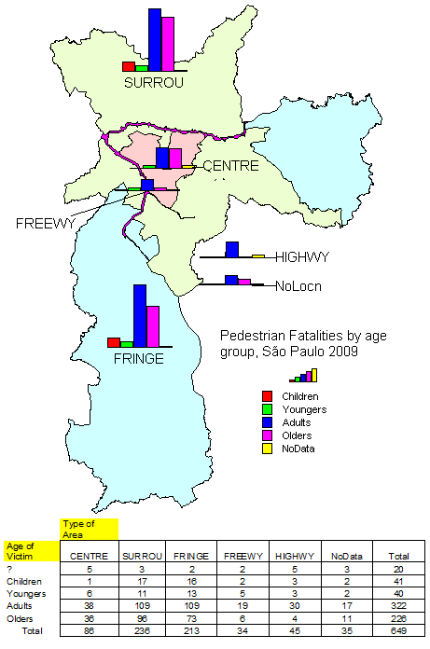

Figure 9.3.5.2.2a – Pedestrian Fatalities in Traffic Accidents by Age Group and Type of Area for the City of São Paulo in 2009

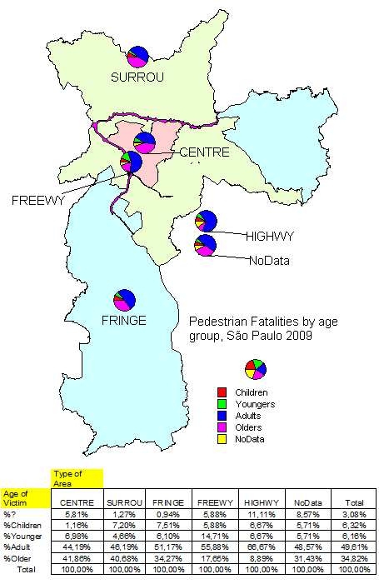

Figure 9.3.5.2.2b – Share of Pedestrian Fatalities in Traffic Accidents by Age Group and Type of Area for the City of São Paulo in 2009

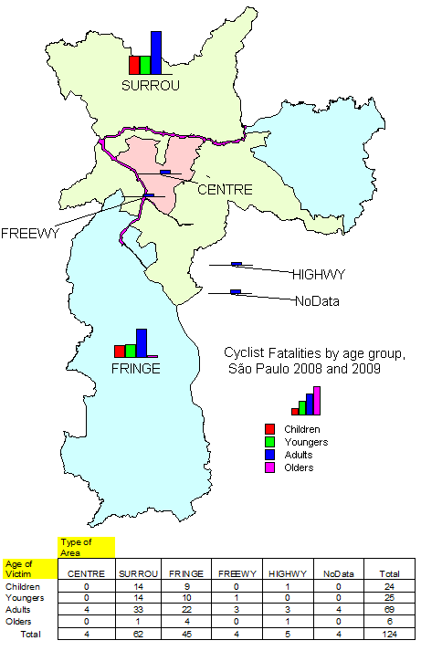

Figure 9.3.5.2.2c – Cyclist Fatalities in Traffic Accidents by Age Group and Type of Area for the City of São Paulo in 2009&8

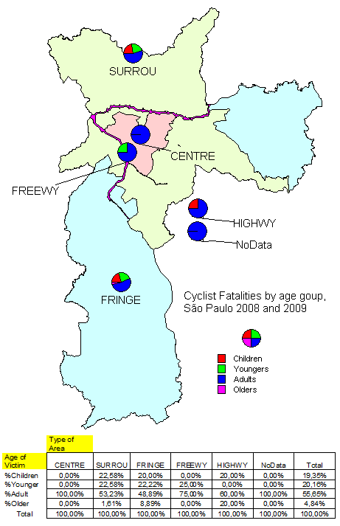

Figure 9.3.5.2.2d – Share of Cyclist Fatalities in Traffic Accidents by Age Group and Type of Area for the City of São Paulo in 2009&8

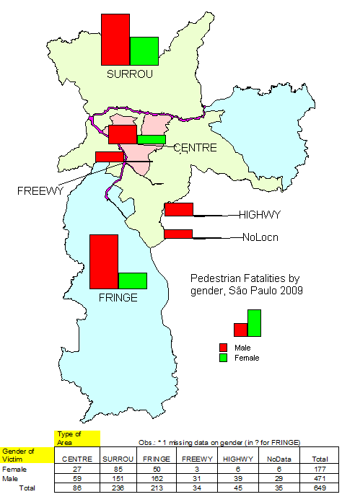

Figure 9.3.5.2.3a – Pedestrian Fatalities in Traffic Accidents by Gender and Type of Area for the City of São Paulo in 2009

– Figure 9.3.5.2.3b share of Pedestrian Fatalities in Traffic Accidents by Gender and Type of Area for the City of São Paulo in 2009

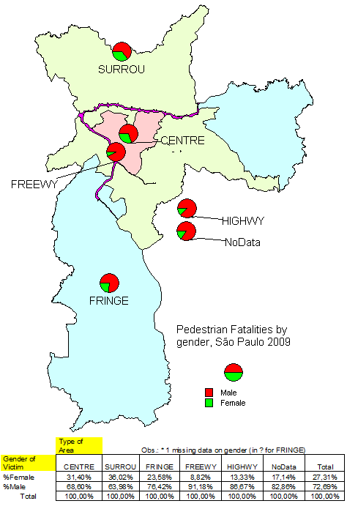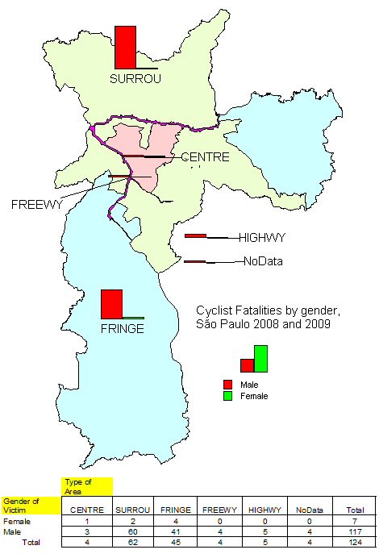

Figure 9.3.5.2.3c – Cyclist Fatalities in Traffic Accidents by Gender and Type of Area for the City of São Paulo in 2009&8

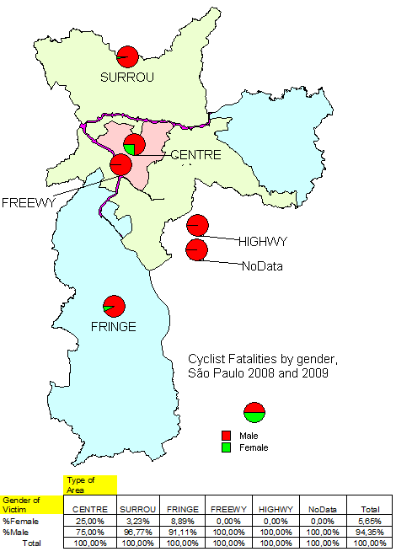

Figure 9.3.5.2.3d – Share of Cyclist Fatalities in Traffic Accidents by Gender and Type of Area for the City of São Paulo in 2009&8

Table 7.3.5.2.1a – Crossed Distribution for Pedestrian Fatalities in Traffic Accidents by Age Group and Gender for the City of São Paulo in 2009

|  |  |  |  |  |  |  |  |  |
| --- | --- | --- | --- | --- | --- | --- | --- | --- |
| Fatal Victims | Pedestrians 2009 |  |  |  |  |  |  |  |
|  | Gender of Victim |  |  | Obs.: * 1 missing data on gender (in ? for Age) | | | |  |
| Age of Victim | Female | %Gen | %Group | Male | %Gen | %Group | Total* | %Group |
| ? | 3 | 15,79% | 1,69% | 16 | 84,21% | 3,40% | 20 | 3,08% |
| Children | 14 | 34,15% | 7,91% | 27 | 65,85% | 5,73% | 41 | 6,32% |
| Youngers | 11 | 27,50% | 6,21% | 29 | 72,50% | 6,16% | 40 | 6,16% |
| Adults | 60 | 18,63% | 33,90% | 262 | 81,37% | 55,63% | 322 | 49,61% |
| Olders | 89 | 39,38% | 50,28% | 137 | 60,62% | 29,09% | 226 | 34,82% |
| Total | 177 | 27,31% | 100,00% | 471 | 72,69% | 100,00% | 649 | 100,00% |

Table 7.3.5.2.1b – Crossed Distribution for Cyclist Fatalities in Traffic Accidents by Age Group and Gender for the City of São Paulo in 2009&8

|  |  |  |  |  |  |  |  |  |
| --- | --- | --- | --- | --- | --- | --- | --- | --- |
| Fatal Victims | Cyclists 2009&8 |  |  |  |  |  |  |  |
|  | Gender of Victim |  |  |  |  |  |  |  |
| Age of Victim | Female | %Gen | %Group | Male | %Gen | %Group | Total* | %Group |
| Children | 2 | 8,33% | 28,57% | 22 | 91,67% | 18,80% | 15 | 22,39% |
| Youngers | 3 | 12,00% | 42,86% | 22 | 88,00% | 18,80% | 16 | 23,88% |
| Adults | 2 | 2,90% | 28,57% | 67 | 97,10% | 57,26% | 34 | 50,75% |
| Olders | 0 | 0,00% | 0,00% | 6 | 100,00% | 5,13% | 2 | 2,99% |
| Total | 7 | 5,65% | 100,00% | 117 | 94,35% | 100,00% | 67 | 100,00% |

On the incidence of fatalities to pedestrians in periods of day shown in Figures 9.3.5.2.4a and 9.3.5.2.4b, the higher incidence in working hours is clear but there is a significant presence in the night period. The incidence in late night hours of week-ends (a period typically relevant for fatalities of vehicle occupants, particularly for the young) is significant, even if not at the same level that could be expected based on other types of accidents. The predominance of the morning peak is more noticeable in the Central areas (also in the Surroundings, in a smaller degree) while the incidence in the afternoon peak and the night period is more relevant in the Fringe areas (in the Surroundings, the night period is the more important).

On the incidence of fatalities to cyclists in periods of day shown in Figures 9.3.5.2.4c and 9.3.5.2.4d, the small number of observed cases does not permit to distinguish a clear pattern of occurrences but for the Surroundings and Fringe areas. In both, data clearly shows the special incidence in morning, afternoon and night periods (between this periods, the incidence was smaller, signing a different pattern if compared to pedestrian fatalities). This pattern can not be exclusively related to peak periods because it occurs also in weekends. The incidence in late night hours of week-ends is even smaller than that for pedestrians.

For both (pedestrians and cyclists), the incidence by day of the week (not shown) is almost equally distributed (no special pattern was also detected by examining the cross-tabulation of period of day and day of the week). This feature suggests the presence of relevant safety problems in predominantly working periods and leisure periods of the day, for both also.

On the incidence of fatalities to pedestrians by vehicle involved shown in Figures 9.3.5.2.5a and 9.3.5.2.5b, data shows that the automobiles are the vehicle type more frequently involved in pedestrian fatalities, being present in 40,1% of them (47,5% of those with the type of vehicle identified). This feature is not surprising as automobiles typically represent around 75% of the vehicle fleet. Nevertheless, it is noticeable that motorcycles are present in 18,8% of pedestrian fatalities (22,3% of those with the type of vehicle identified), larger than its presence in the vehicle fleet (around 12%). As typical in urban areas, buses are also frequently involved in pedestrian fatalities. Of course, this presence can not be compared to their share in fleet because those buses in regular service usually travel 10 to 100 times more than automobiles (the same applies to motorcycles, in a small degree, because a significant part of its fleet is used for delivery services in Brazil). But the presence in 17,7% of pedestrian fatalities (21,0% of those with the type of vehicle identified) is clearly of special concern. Relatively, the presence of automobiles is greater in Central Areas and Highways and that of motorcycles in the Surroundings and Fringe areas. The presence of trucks is noticeable in Freeways and Highways. Last, but not least, the large proportion of pedestrian fatalities with vehicle evasion from the scene of the accident is very large (27,0% most of them related to the cases where the type of vehicle involved was not identified). This feature is clearly abnormal and seems to sign to some of the wounds of Brazilian society.

On the incidence of fatalities to cyclists by vehicle involved shown in Figures 9.3.5.2.5c and 9.3.5.2.5c, the predominance of automobiles is smaller and the presence of large vehicles is point to be highlighted. Automobiles are present in 28,8% of cyclist fatalities (35,6% of those that involved a second vehicle and had this vehicle identified). For buses, the incidence in cyclist fatalities is 26,6% (32,9% of those that involved a second vehicle and had this vehicle identified). For trucks, the incidence in cyclist fatalities is 17,7% (21,9% of those that involved a second vehicle and had this vehicle identified). Even if accounting for their large vehicle use, these incidence levels are clearly of special concern (a clear sign of conflict between the lack of infra-structure that can accommodate both or that can diverge cyclists from using roads with high presence of large vehicles). The incidence of single vehicle accidents (shocks and falls) is also noticeable, reaching 13,7% of cyclist fatalities. Due to the small number of cases, no variation in the pattern of spatial occurrences seems to be credible.

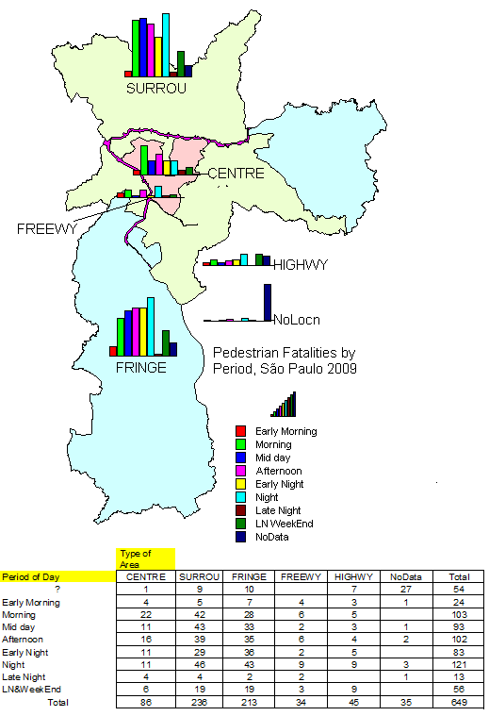

Figure 9.3.5.2.4a – Pedestrian Fatalities in Traffic Accidents by Period of Day and Type of Area for the City of São Paulo in 2009

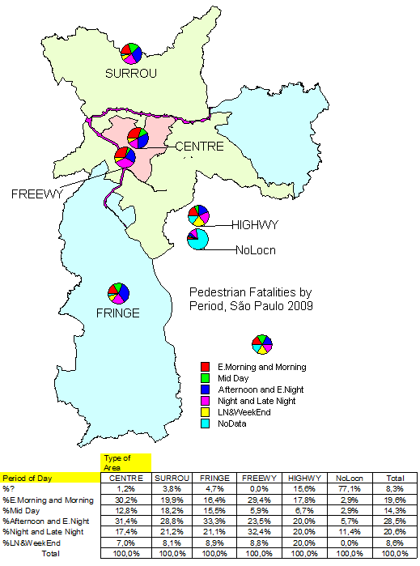

Figure 9.3.5.2.4b – Share of Pedestrian Fatalities in Traffic Accidents by Period of Day and Type of Area for the City of São Paulo in 2009

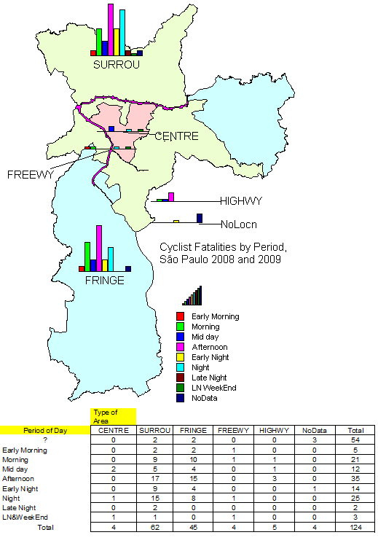

Figure 9.3.5.2.4c – Cyclist Fatalities in Traffic Accidents by Period of Day and Type of Area for the City of São Paulo in 2009&8

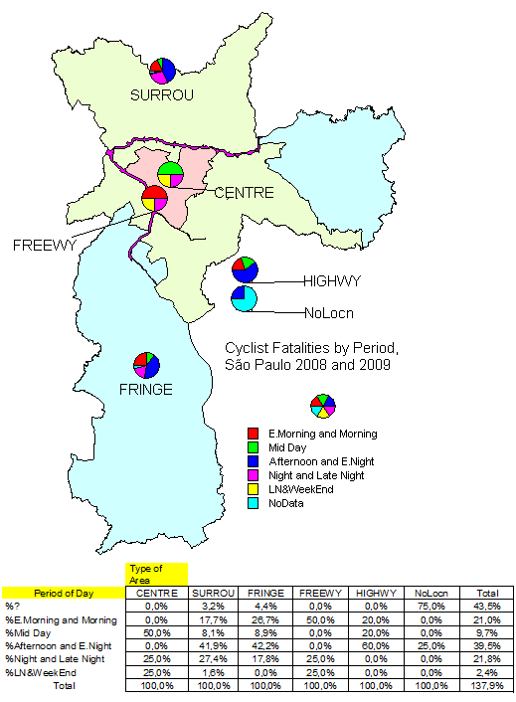

Figure 9.3.5.2.4d – Share of Cyclist Fatalities in Traffic Accidents by Period of Day and Type of Area for the City of São Paulo in 2009&8

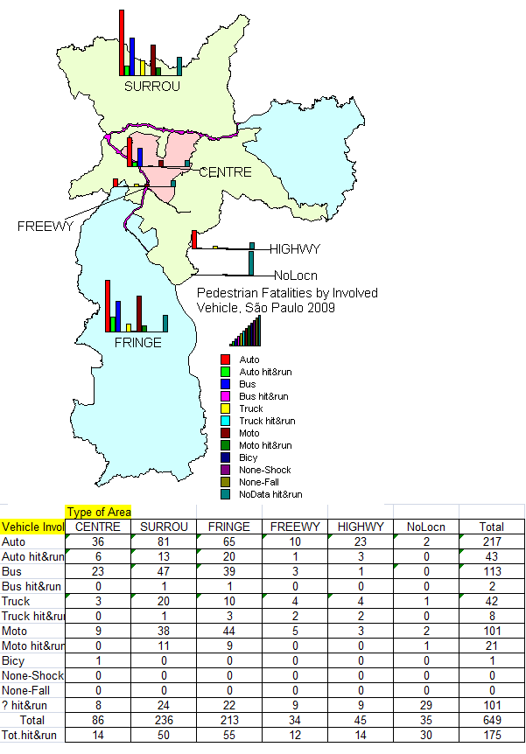

Figure 9.3.5.2.5a – Pedestrian Fatalities in Traffic Accidents by Vehicle Involved and Type of Area for the City of São Paulo in 2009

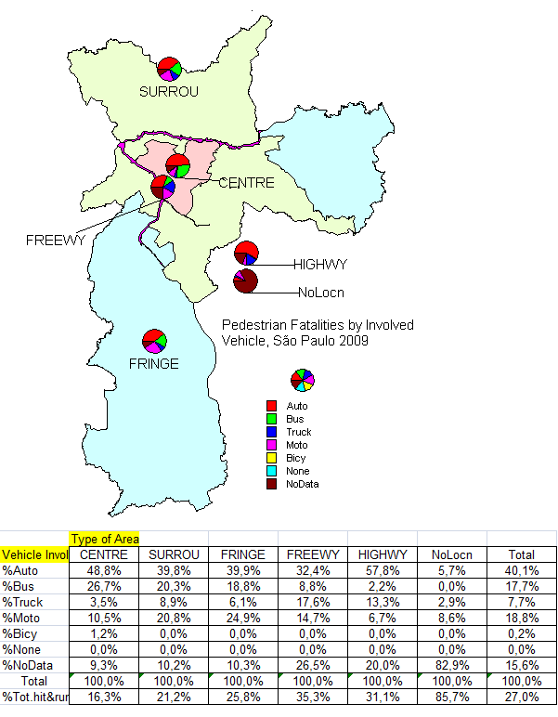

Figure 9.3.5.2.5b – Share of Pedestrian Fatalities in Traffic Accidents by Vehicle Involved and Type of Area for the City of São Paulo in 2009

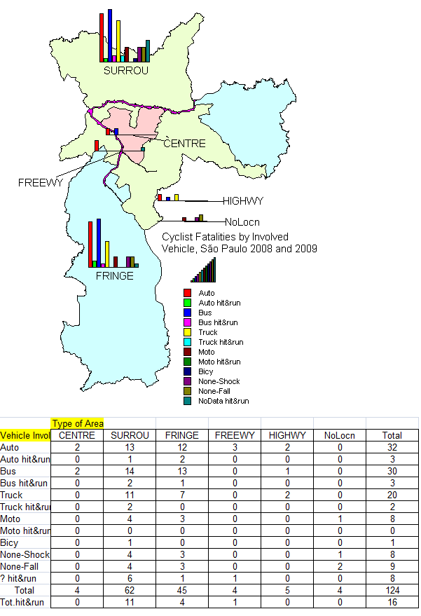

Figure 9.3.5.2.5c – Cyclist Fatalities in Traffic Accidents by Vehicle Involved and Type of Area for the City of São Paulo in 2009&8

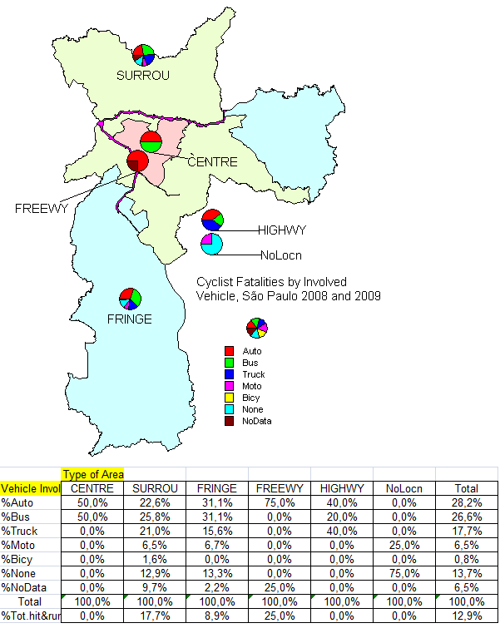

Figure 9.3.5.2.5d – Share of Cyclist Fatalities in Traffic Accidents by Vehicle Involved and Type of Area for the City of São Paulo in 2009&8

# A Preliminary Analysis of Contributory Factors to VUR Accidents in São Paulo

Based on the database of fatal accidents in the City of São Paulo, a preliminary analysis of the factors present in their production was carried-out. This preliminary analysis had 3 tasks:

* Identification of factors mentioned in the (short) accident description;
* Checking of consistency between accident description and factor presence;
* Categorization of factors and calculation of implied factors;
* Redefinition of accident type to match the accident description
* Checking of consistency of accident description and investigation, if available.

(at this moment, the last step was carried-out only for fatal accidents involving cyclists).

Implied factors are those whose presence can be established based on other data recorded about the accident. For example, age class of victims and/or drivers and period of day/type of day of accidents are among them. Some of these factors can be evaluated at least in a first approximation (as the presence of non-licensed drivers, based on their age). Mainly, this procedure was applied to accident information coded in the data gathered from CET/Sp.

The proposed accident typology is based on the initial accident and the presence of accidents in sequence. For the initial accident or the accident in sequence the typology is:

1. Single Vehicle Accident, usually in the Roadside (Out of the Carriage):
   1. Collision with Parked Vehicle (SP)
   2. Collision with Lateral Obstacle (SL)
   3. Collision with Central Obstacle (SC)
   4. Rollover, Overturning or Twirling (SV)
   5. Other (SO, to be described)
2. Vehicle Accident, usually in the Road (In the Carriage):
   1. Rear-end Collision (CR)
   2. Lateral Collision (CL, with the same, turning or opposing flow)
   3. Angular Collision (CA, with crossing or turning flow)
   4. Head-on Collision (CH, with opposing or turning flow)
   5. Collision with backing flow (CB)
   6. Shock with Obstacle in the Road (SR)
   7. Fall of load in the Road (SL)
   8. Other (CC to be described)
3. Vulnerable User Accident in the Road (In the Carriage):
   1. Run-over or Launch of pedestrian or cyclist crossing the Road (UR)
   2. Run-over or Launch of pedestrian or cyclist along the Road (UA)
   3. Run-over of animals in the Road (AR)
   4. Run-over of driver/passenger of motorized vehicles in the Road (MR)
   5. Run-over of driver/passenger of non-motorized vehicles in the Road (NR)
   6. Fall of pedestrian or cyclist in the Road (FR)
   7. Other (UR, to be described)
4. Vulnerable User Accident in the Roadside (Out of the Carriage):
   1. Run-over or Launch of pedestrian or cyclist in the Lateral Area (UL)
   2. Run-over or Launch of pedestrian or cyclist in the Central Area the Road (UC)
   3. Run-over of animals in the Roadside Area (Ar)
   4. Run-over of driver/passenger of motorized vehicles in the Roadside Area (Mr)
   5. Run-over of driver/passenger of non-motorized vehicles in the Roadside Area (Nr)
   6. Fall of pedestrian or cyclist in the Roadside Area (Fr)
   7. Other (Ur, to be described)
5. Other (OA, to be described)

In Brazil, there is a general terminology distinguishing 3 main types of traffic accidents: accidents among motorized vehicles in the traffic are called collisions or crashes (“colisões”), accidents of motorized vehicles and obstacles or other outside elements (including parked vehicles) are called here as shocks (“choques”), accidents with pedestrians, non-motorized vehicles, animals or drivers/passengers outside vehicles are called here as run-over (“atropelamentos”). The frontiers of the general types are not uniformly set by every agency. For example, some agencies classify collisions with vehicles stopped in the traffic (perhaps at a traffic signal) as a shock. Others do not distinguish motorized vehicles from non-motorized vehicles (reserving the word run-over only for accidents with pedestrians or animals). The above proposal takes the opposed view in both points. For accidents with two-wheeler vehicles, the proposal is that they are treated as collisions or falls but that the run-over of their drivers/passengers should be also recorded as a sequence accident if they remain on the road after the initial accident and then is also catch by other vehicles. Note also that the collisions with motorized two-wheeler or three-wheeler vehicles or other (than cycles) non-motorized vehicles should described as simple accidents, if the driver/passenger of such vehicles is not catch by other vehicles in the sequence accident.

Note that a similar terminology is also adopted by other countries but the US and the UK.

The description of each accident was screened also to identify the following information:

* The configuration of the event and of the resulting accident (who/what initiate the rupture of normal operation?, who hits or is hit by whom?, who has right of way?);
* The sequence of events and accidents;
* Pre-conditions for manoeuvres, initiating (or triggering) events, evasive failure factors and aggravating factors;
* General factors that can contribute to the accident occurrence (time of day, day of week, driver age, pedestrian age, among others);
* Specific factors that were mentioned by the accident description.

The intent was to define, for each accident, the dynamic of its occurrence, including:

* The pre-conditions of the event, the desired manoeuvre, the initiating event that produced the rupture phase, the constraints to evasion, the available reaction time, the evasive action pursued, the failure in evasive action, the initial accident, the accident sequence, the aggravating factors present, the outcomes of the accident;
* The contributory factors that made the accident probable, reduced the possibility of evasion or aggravated its outcomes, classified as primary factors (from the user or element that triggered the event), secondary factors (from the other users or elements that actively participated in the event), passive factors (from users or elements that constrained the course of events, even if not participating).

The following analysis is based in the database of factors built from accident data gathered from SAF (and SAT as its complementary source of information). From the beginning, the reliability of this source of data has to be considered. Mainly for fatal accidents to pedestrians and cyclists, both are usually the victim of motorized vehicles and the information provided to officers that fill the records of accidents are often the version of the drivers only (that survived the accident), at least if no other victim or witness is present. Adding to this source of bias, the lack of adequate training of officers on technical matters increases the suspicion on data.

Nevertheless, there at least two reasons that justify this preliminary analysis on contributory factors to accidents based on the SAF database:

* The analysis can provide a first (biased) view on factors to be evaluated further;
* The complementary sources of information (RIF, at least) can provide additional data that could be used to evaluate the degree of bias and omission on SAF data.

Otherwise, there is practical reason underlying the exercise: to discover by how much the conclusions based on SAF database differs from those obtained from more reliable data.

After presenting the results that can be obtained from the database on fatalities built for the project, the potential of improving the reliability of conclusions by adding the information from in-depth investigation also available at CET/Sp will be discussed.

The first question is the availability of information on contributory factors. Tables 7.3.5.3.1a and 7.3.5.3.1b present the number of factors that were identified for each accident. For traffic accidents with pedestrian fatalities in 2009, only 63,9% (415 traffic accidents) had some data that can be interpreted to identify potential contributory factors other than those related to date and time of occurrence and/or the gender and age of road users involved in the accident. For traffic accidents with cyclist fatalities in 2009&8, only 73,4% (91 traffic accidents) had some data of that can be interpreted to identify potential contributory factor.

Table 7.3.5.3.1a – Potential Contributory Factors in Pedestrian Fatalities Data

|  |  |  |
| --- | --- | --- |
| Fatal Victims | Pedestrians 2009 |  |
|  |  |  |
| No.Factors | Total | no detail |
| 0 | 234 | 234 |
| 1 | 165 |  |
| 2 | 127 |  |
| 3 | 86 |  |
| 4 | 32 | some detail |
| 5 | 5 | 415 |
| Total | 649 | 63,9% |

Table 7.3.5.3.1b – Potential Contributory Factors in Cyclist Fatalities Data

|  |  |  |
| --- | --- | --- |
| Fatal Victims | Cyclists 2009&8 |  |
|  |  |  |
| No.Factors | Total | no detail |
| 0 | 33 | 33 |
| 1 | 34 |  |
| 2 | 21 |  |
| 3 | 28 |  |
| 4 | 5 | some detail |
| 5 | 3 | 91 |
| Total | 124 | 73,4% |

The variation of data available by type of area is represented in Figures 9.3.5.3.1a and 9.3.5.3.1b for pedestrian fatalities. Similar data for cyclist fatalities is represented in Figures 9.3.5.3.1c and 9.3.5.3.1d. The predominance of traffic accidents with no information or at most one information (potential contributory factor that could be identified from data) is evidence, being smaller in the Central areas and greater in the Surroundings and Fringe areas.

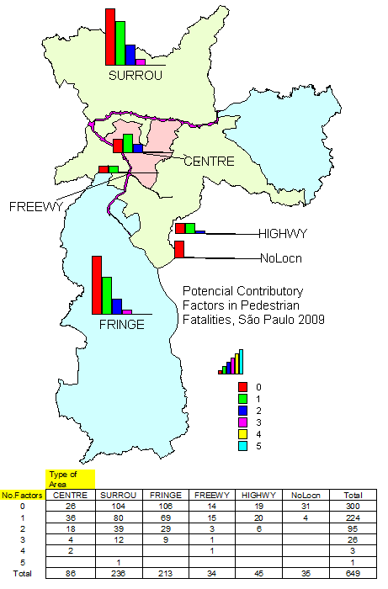

Figure 9.3.5.3.1a – Potential Contributory Factors in Pedestrian Fatalities in Traffic Accidents for the City of São Paulo in 2009

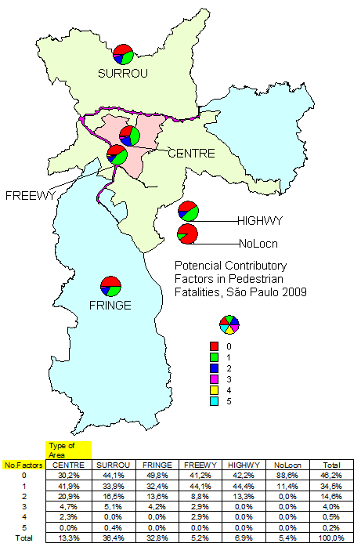

Figure 9.3.5.3.1b – Share of Potential Contributory Factors in Pedestrian Fatalities in Traffic Accidents for the City of São Paulo in 2009

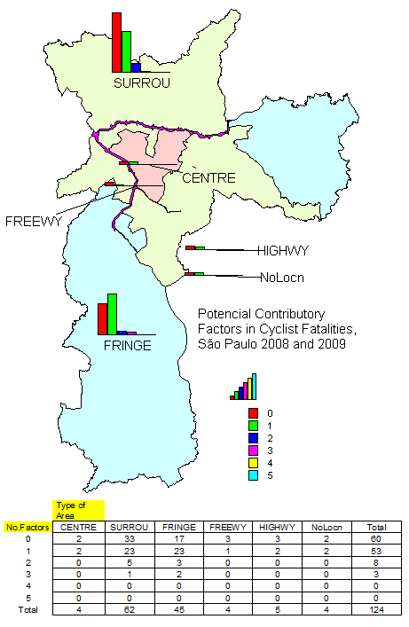

Figure 9.3.5.3.1c – Potential Contributory Factors in Cyclist Fatalities in Traffic Accidents for the City of São Paulo in 2009&8

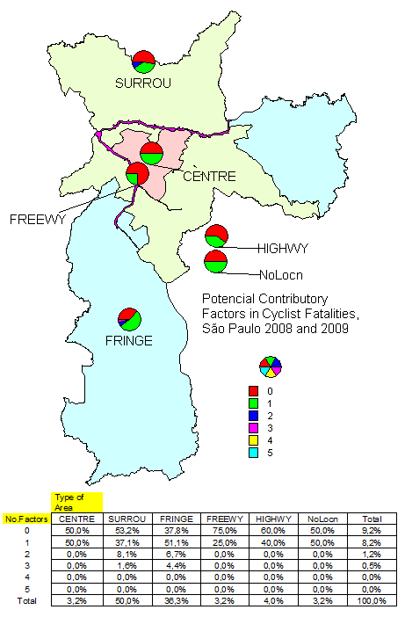

Figure 9.3.5.3.1d – Share of Potential Contributory Factors in Cyclist Fatalities in Traffic Accidents for the City of São Paulo in 2009&8

The type of accidents, corresponding to the initial accident, are shown in Figures 9.3.5.3.2a and 9.3.5.3.2b for pedestrian fatalities and in Figures 9.3.5.3.2c and 9.3.5.3.2d for cyclist fatalities, in aggregate form. The sequence of accidents, if it occurred, was also considered and is shown in Figures 9.3.5.3.3a and 9.3.5.3.3b for pedestrian fatalities and Figures 9.3.5.3.3c and 9.3.5.3.3d for cyclist fatalities, in aggregate form. The aggregation was based on the point of view of the VRU (i.e. other accidents that were not related to the VRU are not represented).

For pedestrian fatalities, almost half the accidents have no detail on where the hit of pedestrian (run-over or launch) occurred. From those pedestrian fatalities for which this information can be recovered, the vast majority occurred on the road (42,4% or 86.9% of those identified) but there are a significant number of them that occurred in out of road, in the central or lateral areas (3,2% 6,6% of those identified). No other single accident (including all types of collisions and shocks) was significant, meaning that run-over are usually the initial accident. This conclusion do not mean that the occurrence of pedestrian accidents as a sequence of accident is unimportant because these secondary accidents can be the cause of the pedestrian fatality and can generate injuries to vehicle occupants. Note that secondary accidents are also more frequently occurring in the roadside (1 to 3 compared to hit on the road for secondary accidents, against 1 to 13 compared to hit on the road in primary accident). Overall, the hit (run-over or launch) of pedestrians out of the road (in the median or in sidewalks) reach 4,4% (or 29) of the fatalities (without considering those whose locus of occurrence were not identified). However, the number of pedestrian fatalities without such detail is very large and the relevance of roadside protection can be even greater. In contrast, the number of fatalities to vehicle occupant in primary or secondary accidents of events with pedestrian fatalities is very small (just 1 in the 649 cases, for a motorcycle driver).

For cyclist fatalities, the initial accident is usually the collision with a motorized vehicle (78,7%) but the number of single vehicle accidents with bicycles is also relevant (19,7%, including 11,5% of falls and 8,2% of shocks). The sequence of accident for cyclists in a relevant aggravating factor as 7,3% of them (or 45,3% of those with secondary accident) resulted in the run-over the cyclist and other 7,3% of them (or 45,3% of those with secondary accident) resulted in the fall of the vehicle and the run-over the cyclist (both present). Other secondary accidents are usually shocks.

No clear pattern of variation on the types of areas can be verified for both VRUs groups.

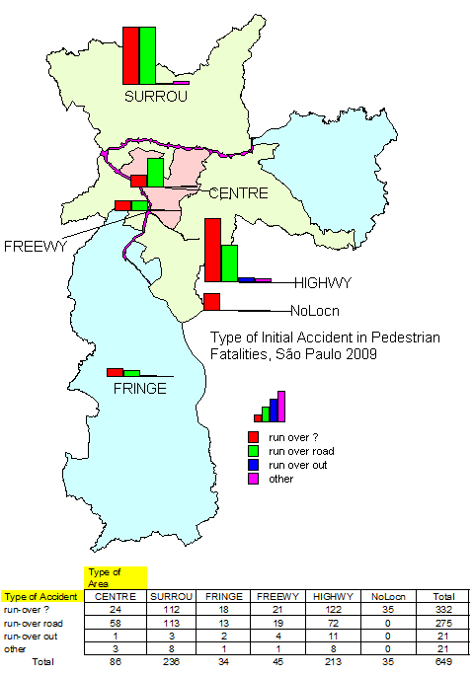

Figure 9.3.5.3.2a – Type of Accident in Pedestrian Fatalities in Traffic Accidents for the City of São Paulo in 2009

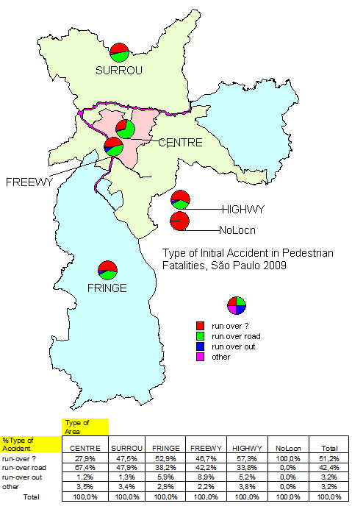

Figure 9.3.5.3.2b – Share of Type of Accident in Pedestrian Fatalities in Traffic Accidents for the City of São Paulo in 2009

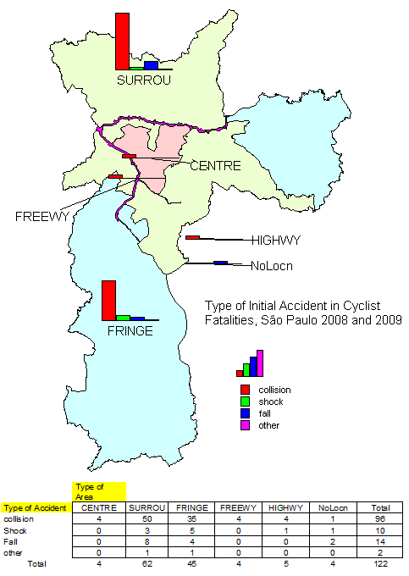

Figure 9.3.5.3.2c – Type of Accident in Cyclist Fatalities in Traffic Accidents for the City of São Paulo in 2009&8

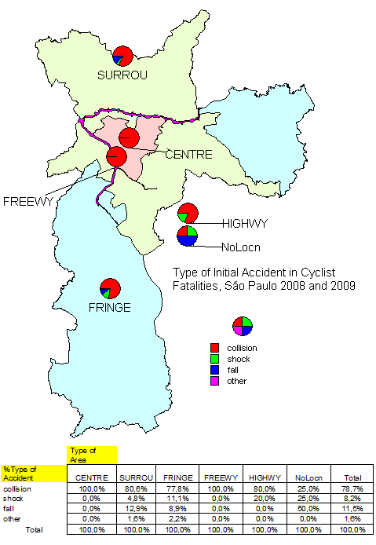

Figure 9.3.5.3.2d – Share of Type of Accident in Cyclist Fatalities in Traffic Accidents for the City of São Paulo in 2009&8

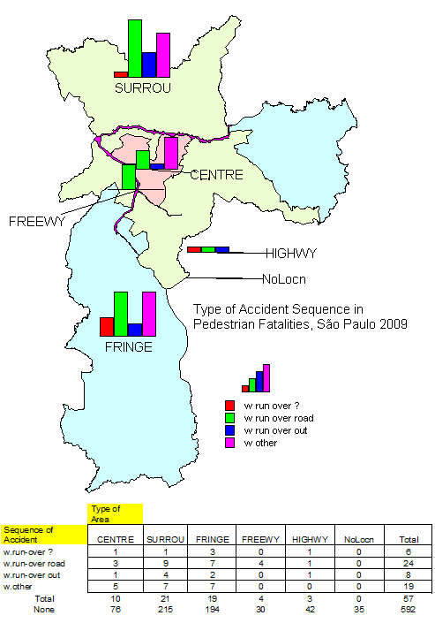

Figure 9.3.5.3.3a – Sequence of Accident in Pedestrian Fatalities in Traffic Accidents for the City of São Paulo in 2009

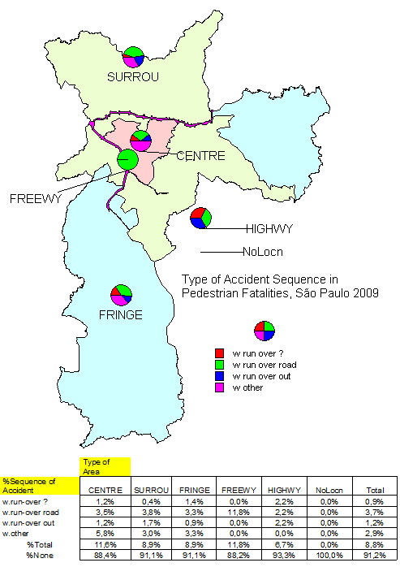

Figure 9.3.5.3.3b – Share of Sequence of Accident in Pedestrian Fatalities in Traffic Accidents for the City of São Paulo in 2009

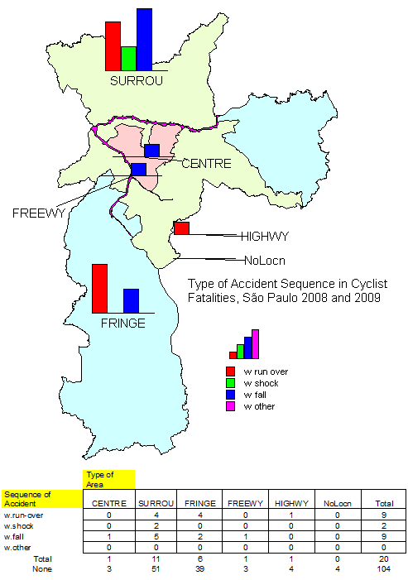

Figure 9.3.5.3.3c – Sequence of Accident in Cyclist Fatalities in Traffic Accidents for the City of São Paulo in 2009&8

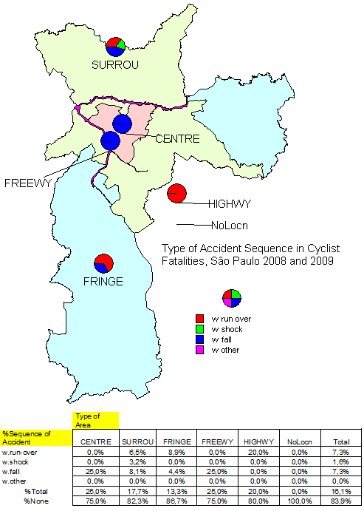

Figure 9.3.5.3.3d – Share of Sequence of Accident in Cyclist Fatalities in Traffic Accidents for the City of São Paulo in 2009&8

In Table 7.3.5.3.2a and 7.3.5.3.2b, the potential contributory factors that could be identified from such information are summarized for traffic accidents with pedestrian fatalities and with cyclist fatalities. Instead of discussing the results in these tables, one should remember the shortcomings of data from police reports, mainly for fatal accidents of pedestrians and cyclists (for which the version of the driver of the vehicle may be the only source), and evaluate the kind of information that could be recovered from the accident description. For pedestrian fatalities, the large number of hit and run accidents should also be remembered.

Further analysis would have to apply better criteria or search for better data. Nevertheless, before discussing the reliability of this information, some points deserve quotation.

For pedestrian fatalities, the presence of young drivers is noticeable (16,0% or 25,1% of the pedestrian fatalities with some detail). This participation is equally divided in absolute number between automobile and motorcycle drivers. The incidence on children and teenagers is also relevant and was previously commented. For other factors, the small presence of some traditional candidates for contributory factors may have some meaning. The main one is speeding but its absence can be attributed to the kind of data used. Also, the number of fatalities related to aggressive behaviour from pedestrians or crossing against queues of vehicles seems to be under the figures suggested by stories. Others may surprise. A significant number of fatalities related to unusual manoeuvres (as backing movements of vehicles) or loss of control (resulting in run-over in sidewalks). Some of these conclusions seem to be warranted by police reported data (as no source of bias can be identified).

For cyclist fatalities, the presence of loss of control and fall of bicycles is noticeable (26,4% of the cyclist fatalities with some detail). The incidence on children and teenagers is also relevant and was previously commented. The presence of vehicle parking and bicycle crossing may also be relevant. Other factors are hardly significant in police reported data.

The classification of factors as contributory (primary, secondary or passive) and the distinction of the desired manoeuvre, the pre-conditions of manoeuvre, the initiating event and the aggravating factors were possible in general, at least for records with some details. However, no accident had a clear cue on the reason for the failure of evasive action. The assessment of vehicle speed and available reaction time seem to be missed relevant data.

A short analysis of data reliability was possible, given the availability of in-depth investigations of accidents in the City of São Paulo (the RIFs). Using 12 in-depth reports on accidents with cyclist fatalities in 2009&8 (from the 124 police reported), a qualitative comparison of the accident description can be made using Table 7.3.5.3.3. Despite the similarity of descriptions, some factors were missing from the SAF short version (e.g. the contribution of bus stops or pavement and sidewalk defects). However, several factors were also missing in both versions. The more notable one is speeding. No report evaluated vehicle speed and made an assessment of its contribution to the occurrence of the traffic accident. Again, the understanding of failure to evade from the accident risk is totally missing.

The improvement of methods used in the in-depth investigation of the accidents should be considered and the possibility of applying them retrospectively to the past RIFs evaluated.

Table 7.3.5.3.2a – Presence of Potential Contributory Factors in Traffic Accidents with Pedestrian Fatalities in 2009, for the City of São Paulo, Brazil

|  |  |  |  |  |  |
| --- | --- | --- | --- | --- | --- |
| C.Factors |  | Total | %Total | %Info | Note |
| Triggering | Driver | 73 | 11,2% | 17,6% |  |
|  | Pedestrian | 298 | 45,9% | 71,8% |  |
| Alcohol | Driver | 12 | 1,8% | 2,9% |  |
|  | Pedestrian | 18 | 2,8% | 4,3% |  |
| Medical | Driver | 2 | 0,3% | 0,5% |  |
|  | Pedestrian | 2 | 0,3% | 0,5% |  |
| PedAge | Children | 26 | 4,0% | 6,3% | pedestrian under 9 |
|  | Teenager | 14 | 2,2% | 3,4% | pedestrian 9 or older |
| PedDisability | Sensory | 2 | 0,3% | 0,5% | pedestrian with visual or mental disability |
|  | Physical | 2 | 0,3% | 0,5% | pedestrian in a wheel-chair |
| Intentional | Driver | 1 | 0,2% | 0,2% | evidence of homicidal act |
|  | Pedestrian | 9 | 1,4% | 2,2% | evidence of suicidal act |
| RoadDefect | Lighting | 7 | 1,1% | 1,7% |  |
|  | Signing | 5 | 0,8% | 1,2% |  |
| RoadCurve |  | 6 | 0,9% | 1,4% |  |
| BusStop |  | 8 | 1,2% | 1,9% |  |
| RedRunning | Driver | 2 | 0,3% | 0,5% |  |
|  | Pedestrian | 37 | 5,7% | 8,9% |  |
| PedCrossing | Outside | 77 | 11,9% | 18,6% | do not include inadequate crossings (13) |
|  | Inside | 7 | 1,1% | 1,7% | some occurs with pedestrian signal in red (3) |
| PedFaults | Careless | 27 | 4,2% | 6,5% |  |
|  | Hided | 9 | 1,4% | 2,2% |  |
|  | Running | 22 | 3,4% | 5,3% |  |
|  | Unforeseen | 4 | 0,6% | 1,0% |  |
|  | Risking | 7 | 1,1% | 1,7% |  |
|  | Queue | 12 | 1,8% | 2,9% |  |
|  | Fall | 7 | 1,1% | 1,7% |  |
| Handcarts |  | 6 | 0,9% | 1,4% |  |
| VehFaults | Loss Control | 22 | 3,4% | 5,3% |  |
|  | Excess Speed | 8 | 1,2% | 1,9% |  |
|  | Careless | 32 | 4,9% | 7,7% | Usual or unusual manoeuvres without due care |
|  | Evasion | 8 | 1,2% | 1,9% |  |
|  | Other Acc | 15 | 2,3% | 3,6% |  |
| Licensing | Too young | 6 | 0,9% | 1,4% | under license age (18 in Brazil) |
|  | Young | 104 | 16,0% | 25,1% | between 18 but under 25 years old |
| RoadService | Vehicle | 12 | 1,8% | 2,9% |  |
|  | Pedestrian | 3 | 0,5% | 0,7% |  |

Table 7.3.5.3.2b – Presence of Potential Contributory Factors in Traffic Accidents with Cyclist Fatalities in 2009&8, for the City of São Paulo, Brazil

|  |  |  |  |  |  |
| --- | --- | --- | --- | --- | --- |
| C.Factors |  | Total | %Total | %Info | Note |
| Triggering | Driver | 8 | 6,5% | 8,8% |  |
|  | Cyclist | 53 | 42,7% | 58,2% |  |
| Alcohol | Driver | 1 | 0,8% | 1,1% |  |
|  | Cyclist | 1 | 0,8% | 1,1% |  |
| Medical | Driver | 0 | 0,0% | 0,0% |  |
|  | Cyclist | 0 | 0,0% | 0,0% |  |
| CycAge | Children | 4 | 3,2% | 4,4% |  |
|  | Teenager | 20 | 16,1% | 22,0% |  |
| CycDisability | Sensory | 0 | 0,0% | 0,0% |  |
|  | Physical | 0 | 0,0% | 0,0% |  |
| Intentional | Driver | 0 | 0,0% | 0,0% |  |
|  | Cyclist | 0 | 0,0% | 0,0% |  |
| RoadDefect | Lighting | 1 | 0,8% | 1,1% |  |
|  | Signing | 0 | 0,0% | 0,0% |  |
| RoadCurve |  | 3 | 2,4% | 3,3% |  |
| Downgrade |  | 3 | 2,4% | 3,3% |  |
| RedRunning | Driver | 0 | 0,0% | 0,0% |  |
|  | Cyclist | 1 | 0,8% | 1,1% |  |
| CycFacility | Outside | 0 | 0,0% | 0,0% |  |
|  | Inside | 0 | 0,0% | 0,0% |  |
| CycFaults | Loss Control | 13 | 10,5% | 14,3% |  |
|  | Fall | 13 | 10,5% | 14,3% |  |
|  | Ride | 5 | 4,0% | 5,5% |  |
|  | Careless | 3 | 2,4% | 3,3% | Usual or unusual manoeuvres without due care |
|  | Crossing | 9 | 7,3% | 9,9% |  |
|  | Overtaking | 3 | 2,4% | 3,3% |  |
|  | WrongWay | 2 | 1,6% | 2,2% |  |
|  | HighSpeed | 2 | 1,6% | 2,2% |  |
| VehFaults | Parking | 6 | 4,8% | 6,6% |  |
|  | Turning | 2 | 1,6% | 2,2% |  |
|  | Overtaking | 1 | 0,8% | 1,1% |  |
|  | Careless | 2 | 1,6% | 2,2% | Usual or unusual manoeuvres without due care |
|  | HighSpeed | 2 | 1,6% | 2,2% |  |
| Licensing | Too young | 1 | 0,8% | 1,1% | under license age (18 in Brazil) |
|  | Young | 6 | 4,8% | 6,6% | between 18 but under 25 years old |
| RoadService | Vehicle | 0 | 0,0% | 0,0% |  |
|  | Pedestrian | 0 | 0,0% | 0,0% |  |

Table 7.3.5.3.3 – Comparison of Accident Description from SAF and RIF Data in Traffic Accidents with Cyclist Fatalities in 2009&8, for the City of São Paulo, Brazil

|  |  |  |
| --- | --- | --- |
| RIF | Description from Police Record | Description from RIF |
| 640/2008: 06/03/2008, Thursday, 15h20min | Cyclist riding on the sidewalk, lost control and collided with the Bus. | Bicycle riding on the sidewalk, when it lost equilibrium by unknown causes, went out of the sidewalk to the near lane, collided laterally with the Bus that was standing in the Bus Stop for boarding and alighting passengers. Road with median and 3 lanes per direction. Pavement and sidewalk in good condition; lighting and signing in good condition. Straight and level segment. Weather was good. Vehicles in good condition. Fatal Victim: man, 40 years old, no protective device. |
| 648/2008: 12/03/2008, Wednesday, 16h15min | Cyclist was passing between the Bus and the Truck, then lost control and fell. | Bicycle tried to overtake a Bus standing at the Bus Stop for boarding and alighting passengers, then lost equilibrium, rolled-over and fell, being run-over by the Truck. Road with median and 3 lanes per direction. Pavement and sidewalk in good condition; lighting and signing in good condition. Straight segment and with a small downgrade. Weather was good. Vehicles in good condition. Fatal Victim: man, 22 years old. |
| 696/2008: 30/04/2008, Wednesday, 23h15min | Cyclist collided with Auto and then was run-over. | Auto hit the Bicycle when crossing a signalized junction. Cyclist was launched to 25 meters. No information about red running. Main road has median (with New Jersey Barrier and no sidewalk) and 3 lanes per direction. Minor road is one-way. Pavement and sidewalk in good condition; lighting and signing in good condition. Straight and level segment. Weather was good. Vehicles in good condition. Fatal Victim: man, approximately 25 years old. |
| 736/2008: 16/06/2008, Monday, 13h20min | Cyclist lost equilibrium,, hit the Truck and then fell. | Children was riding on the sidewalk, then lost equilibrium and rolled-over and fell, being run-over by the Truck. One-way road with 1 lane. Pavement and sidewalk in good condition; lighting and signing in good condition. Straight and level segment. Weather was good. Vehicles in good condition. Fatal Victim: boy, 05 years old, no helmet. |
| 770/2008: 31/07/2008, Thursday, 15h10min | Wet pavement, made Cyclist to loss control and collide with Auto in the opposed flow. | Bicycle was riding in speed, on a downgrade and in the wrong-way when saw a service Truck working in the road and turn to the right and collided with the Auto that was using the lane designated by the work zone signing at the site. Two-lane road with 1 lane per direction. Pavement and sidewalk in bad condition; lighting and signing in bad condition. Straight segment with strong downgrade. Weather was good but pavement was wet (outage of water that was the reason of the road service). Vehicles in good condition. Fatal Victim: man, 26 years old, no helmet. |
| 892/2008?: 10/01/2009, Saturday, 14h40min | Cyclist was overtaking the Bus by the right and was collided and run-over. | Boy was riding and tried to overtake the Bus by the right when the Bus started a right turn and caused the roll-over and fall of the bicycle then run-over by the Bus. The accident occurred at the collector road of the main road, operating as a two-lane road with 1 lane per direction. Pavement is regular, pothole could be the cause of loss of control, and sidewalk is missing. Signing in good condition. Weather was good. Vehicles in good condition. Fatal Victim: boy, 09 years old. |
| 893/2009: 14/01/2009, Wednesday, 11h55min | Cyclist collided with Bus, fell and was run-over. | Bus was running in the right lane and collided laterally with a Bicycle riding in the same direction beside the kerb of the road, then cyclist lost control, rolled-over, fell and was run-over by the Bus. Main road with median and 4 lanes per direction. Pavement and sidewalk in good condition; lighting and signing in good condition. Straight and level segment. Weather was good. Vehicles in good condition. Fatal Victim: woman, 30 years old, with helmet. |

Table 7.3.5.3.3 – Comparison of Accident Description from SAF and RIF Data in Traffic Accidents with Cyclist Fatalities in 2009&8, for the City of São Paulo, Brazil (continuation)

|  |  |  |
| --- | --- | --- |
| 1030/2009: 02/07/2009, Thursday, 5h50min | Collision of Truck and Bicycle. | Truck was running on the middle lane when it struck a bicycle that was crossing the road, then the cyclist fell ahead of the Truck and was run-over. Major road with median and 3 lanes per direction. Pavement and sidewalk in good condition; lighting and signing in good condition. Bend to the left but level segment. Weather was good but fog was present. Vehicles in good condition. Fatal Victim: man, 41 years old. |
| 1045/2009: 16/07/2009, Thursday, 07h50min | Cyclist collided with the rear of the Bus (that escaped) and was run-over by other Bus. | Bus was running in the right lane and reduced the speed when approaching its Bus Stop to start the boarding of passengers. Bicycle just behind the Bus tried to swerve but collided with the rear-end of the Bus, lost control, fell to the left and was run-over by another bus. Major road with median and 3 lanes per direction (the central lane is used for a busway). Pavement and sidewalk in good condition; signing in bad condition. Straight segment in small upgrade. Weather was good. Vehicles in good condition. Fatal Victim: man, 24 years old. |
| 1077/2009: 27/08/2009, Thursday, 10h00min | Cyclist lost equilibrium and shocked against a tree, then fell and was run-over by the Bus. | Boy was working in selling strawberries and was riding with a box of strawberries in one hand when was surprised by a Bus overtaking him, then lost equilibrium, shocked a tree and fell under the Bus that run-over him. Two-lane road with 1 lane per direction. Pavement and sidewalk in good condition; signing in good condition. Small upgrade before a bend. Weather was good. Vehicles in good condition. Fatal Victim: man, 16 years old. |
| 1095/2009: 11/09/2009, Friday, 20h40min | Cyclist took a ride on the Bus by the bumper and collided with other Bus when dropped. | Cyclist was taking a ride by catching the rear bumper of the Bus. When the Bus gained speed, the Cyclist lost control, and encroached into the opposing lanes, colliding laterally with another bus running in the opposed direction, then fell and was run-over. Road with no median and 2 lanes per direction. Pavement and sidewalk in good condition; signing in good condition. Straight segment with small upgrade/downgrade. Weather was good. Vehicles in good condition. Fatal Victim: boy, 15 years old. |
| 1166/2009: 12/12/2009, Saturday, 15h37min | Father with health problem asked his 14 years old son to drive the Truck. Run-over the Pedestrian. | Children was in the sidewalk with his bicycle and encroached the right lane of the road, near the kerb of the road, when the Truck was passing and run-over the head of the children. The Truck was being driven by a 14 years old boy with the presence of his father as passenger and stopped only 150meters ahead of the site. Two-lane road with 1 lane per direction. Pavement in good condition; the sidewalk is narrow and has a step that could contribute to the loss of equilibrium of the cyclist; signing in good condition. Straight segment with small upgrade. Weather was good. Vehicles in good condition. Fatal Victim: boy, 04 years old. |

# A General View on the Relevance and Reliability of Data and Conclusions from Data of São Paulo

The data presented previously have shown that the City of São Paulo has a better prospect in the road safety area in Brazil, being able to reduce the number of fatalities in all types of accidents but those of motorcycles. Even accounting for the dramatic increase in fatalities where motorcyclists are the victims or the aggressor, overall figures are diminishing at a significant but insufficient rate. Compared to London, as an example, the number of fatalities or the fatality rates of the City of São Paulo are clearly astonishing high.

This picture seems to be real as data quality in the City of São Paulo is much better compared to national data. However, since 2005 (following a hole in data from 2002 to 2004), reliance in data on fatal accidents and their fatalities was forced (data on injury accident is worse than before as for PDO accidents). The availability of complementary data gathered by their own technical personnel is, nevertheless, of notice (including a sample of in-depth reports investigating fatal and serious accidents that were collected bi trained analysts of the Traffic Safety Management of the CET/Sp-Traffic Engineering Company.

This report analysed data from a new fatal accident database built over the fatal accident information system (SAF) with information on accidents with pedestrian fatalities in 2009 and accidents with cyclist fatalities in 2009 and 2008. This database is being enlarged by adding accidents in the previous years (2008 for pedestrians and 2007 for cyclists). For the same period, the complementary reports on investigations of fatal and serious accidents (RIF) were gathered. Data on accidents with cyclist fatalities were analysed and analysis is proceeding.

Detailed accident typing could be applied and a number of factors could be identified for a large number of accidents from SAF, including the identification of pre-conditions for manoeuvre, initiating event and aggravating factors. Only the reasons for failure of the evasive action were not identified, due to missing information on key accident data as available reaction time and vehicle speed. The additional information from RIF do not alter this situation. This calls for the revision of the procedure used for in-depth investigation of accidents, as a path to supplementing the database.

The main features of fatal accidents and their fatalities were faithfully determined based on the project database: the predominance of pedestrians as fatal victims of accidents (despite a small decrease), the increase in the share and level of motorcyclist fatalities and, to a much smaller degree, of cyclists also, the significant decrease in the level and share of vehicle occupant fatalities. Details on the incidence of fatalities were also determined: the unusual presence of women as victims of pedestrian fatalities (even if smaller than men), the general predominance of male victims among cyclists (except among youngers), the high incidence in children and olders (specially for vulnerable road users and mainly for children among cyclists and even both among pedestrians). The predominance of VRU accidents in peak periods and the early night as well as its evenly distribution on days of the week was also established. Incidence by type of accident was also studied but some relevant missing points were identified (as the place where the pedestrian is hit or the reason for loss of control).

Some of these conclusions were analysed in a spatial context. The predominance of accidents in the Surroundings and Fringe types of area were established. In these area types, factors and features related to residential activities usually appeared more frequently (as fatalities to children, olders and women). The same applies to high speed roads. Nevertheless, the effect of the lack of infra-structure (as a depressor of travel desires) was mentioned several times as a potential explanation for the reduced occurrence of some types of accidents in some types of area (instead as the safety of roads).

The confidence in contributory factors identified based on the SAF database is debatable but several points can be taken as firm: the presence of automobiles and motorcycles as main aggressors of pedestrians and of buses and trucks as main aggressors of cyclists in fatal accidents; the high presence of young drivers (in automobiles and motorcycles) as aggressors of pedestrians, the significant number (even if not predominant) of pedestrian fatalities out of the road (from encroachments to the median or sidewalks), of cyclist fatalities due to shocks and falls due to loss of control of bicycles, among other examples. Some other factors are brought by the RIF database, as cyclist fatalities generated near Bus Stops. Better analysis methods can be the key to improve the reliability in the data availability.

# References

CET/Sp (1998) – “**Facts and Statistics on Traffic Accidents in São Paulo – 1997**”, CET/Sp-Traffic Engineering Company of the Prefecture of São Paulo, Municipality of São Paulo, Brazil (in portuguese).

CET/Sp (2001) – “**Facts and Statistics on Traffic Accidents in São Paulo – 2000**”, CET/Sp-Traffic Engineering Company of the Prefecture of São Paulo, Municipality of São Paulo, Brazil (in portuguese).

CET/Sp (2006) – “**Fatal Traffic Accidents in the Municipality of São Paulo – 2000**”, CET/Sp-Traffic Engineering Company of the Prefecture of São Paulo, Municipality of São Paulo, Brazil (in portuguese).

CET/Sp (2010) – “**Fatal Traffic Accidents in the Municipality of São Paulo – 2009**”, CET/Sp-Traffic Engineering Company of the Prefecture of São Paulo, Municipality of São Paulo, Brazil (in portuguese).

DATASUS (2010) – “**Information on Health – Vital Statistics**”, Health Department (Ministério da Saúde), Federal Republic of Brazil, http://www2.datasus.gov.br/DATASUS/index.php?area=02, accessed in April/2010 (in portuguese).

Paula, M.E.B. (2009) – “**Databases on Traffic Accidents held by CET**”, internal communication, CET/Sp-Traffic Engineering Company of the Prefecture of São Paulo, Municipality of São Paulo, Brazil (in portuguese).

SEADE (2010) – “**Information on Municipalities in the State of São Paulo**”, SEADE-Foundation State Data Analysis System, State of São Paulo, Brazil, http://www.seade.sp.gov.br/produtos/imp/index.php, accessed in April/2010 (in portuguese).